

Arduino based Web Server for Environmental Control

Final Product Documentation and Report  
  
CI301: Individual Project

Ian Smith

Table of Contents

Interim Planning Report Update 3

Project Management Methodology Update 3

Required Hardware 4

Required Software Dependencies 6

Development 7

Time management 12

Usability/Objectives 13

Testing 16

No Internet access 17

Incorrect MySQL details 17

Power on and serial monitor test 18

Webpage access and access times 19

Relay dimming with LEDs 20

Main Board 20

Dimmable hardware (LEDs, many fans, some household lights) 20

Non-dimmable hardware 21

Secondary Board 22

Database Design 23

Evaluation 25

References 26

Ethics Form 27

# Interim Planning Report Update

## Project Management Methodology Update

It has been brought to my attention that the interim report is lacking in some detail on how I wish to conduct research for certain software and hardware issues. I will spend time performing key areas of research that I know will be required before starting the development stage, and will allow some reserved time for finding solutions to issues when any errors occur or I require guidance. Generally I will aim for a waterfall based lifecycle as specified in detail during the previously specified timeline, however should I fall short on time I will adapt a more Feature Driven development strategy, focusing on getting key modules working to a high standard.

# Required Hardware

I decided to purchase the hardware that was guaranteed to work with the steps I want to take, as found out by my background research. I originally stated I would use one arduino and in hindsight I could have got the scheduling to work sufficiently on one board, however, this way I would be able to provide software updates for the final product to allow multicore processing and distribute the computation load between the two board’s processors to allow higher performance on the webserver aspect.

1 x Arduino Mega 2560 development board

1 x Arduino Uno development board

1 x Ethernet WIZnet W5100 based shield

1 x USB A-B cable

1 x Ethernet network connection, Internet access and cable

1 x Breadboard

4 x LED [to simulate relays during testing]

4 x Solid-state relays

4 x DHT11 sensors (plus a spare)

1 x Cable kit including male - male and male - female connectors

After obtaining all the required hardware I connected the Ethernet shield to the Mega board, then linked power and ground across the boards and the breadboard so both turn on when one cable is connected and we have power rails on the breadboard.

**The final hardware arrangement consists of**

Mega – Ethernet Shield

Mega – USB to PC

Shield Ethernet – Internet access

Shield TX – Uno RX for sending PWM values to the second arduino.

Shield 5V – Uno 5V for shared power

Shield Ground – Uno Ground for shared power

Shield Analog0 – DHT11 Sensor 0

Shield Analog1 – DHT11 Sensor 1

Shield Analog2 – DHT11 Sensor 2

Shield Analog3 – DHT11 Sensor 3

Uno Digital6 – LED (+) and Relay

Uno Digital9 – LED (+) and Relay

Uno Digital10 – LED (+) and Relay

Uno Digital11 – LED (+) and Relay

The Mega in the future would handle obtaining and inserting database values that are passed from the Uno through their RX (receiver) and TX (transmitter) pins. At the end of development the Mega currently does all the processing and simply sends a PWM value and the desired relay to the Uno via it’s TX port. The Uno simply waits for a message from the Mega, and could be used a lot more by having the DHT sensors attached to it instead of the Mega. The Uno could then handle the temperature changes and simply transmit temperature changes to the Mega to be published online to the MySQL server, and stored locally for webserver use. At this point in time the relays (and/or LEDs) are attached to the Uno, and the DHTs are attached to the Mega.

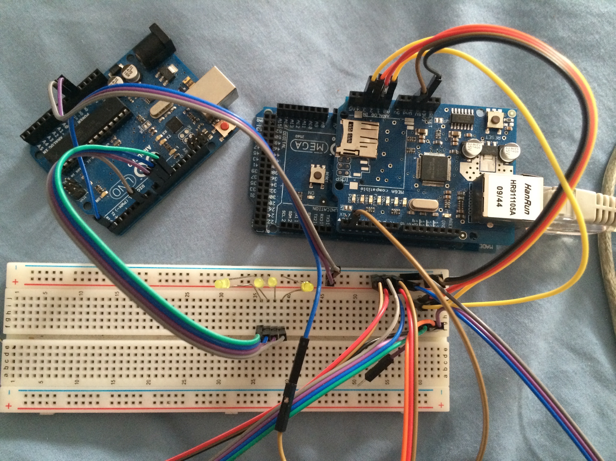

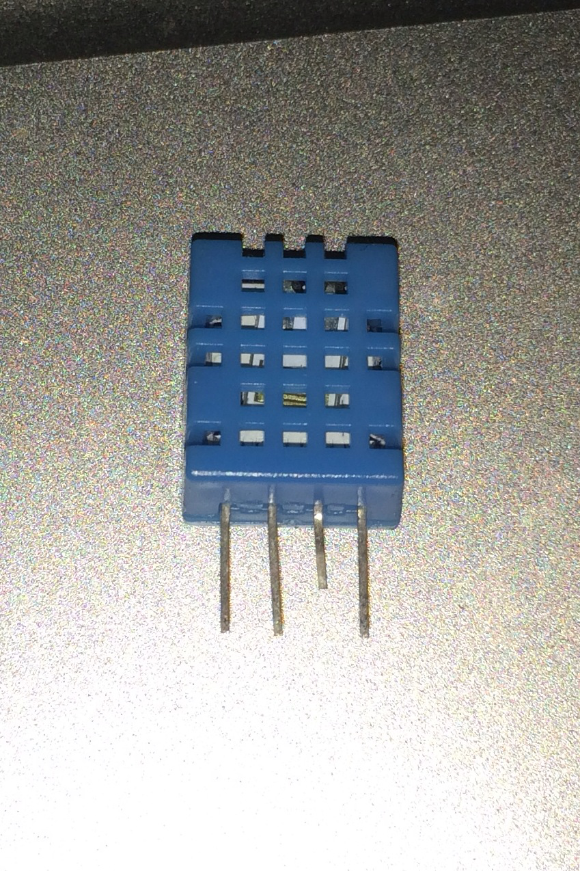The DHT connector held like this will have a 5v cable to its leftmost pin, a signal (data) cable to its second pin and a ground cable to its rightmost pin. These are visible to the right of the breadboard and are the 4 sets of cables leading off the bottom of the above image.

Here I have used LEDs, and have been using this system for some time (with Ethernet disabled) to monitor and adjust heat mats for a small snake using a solid state relay set up like the image below, plugged into the relay data pin and ground the same as the LEDs are above.

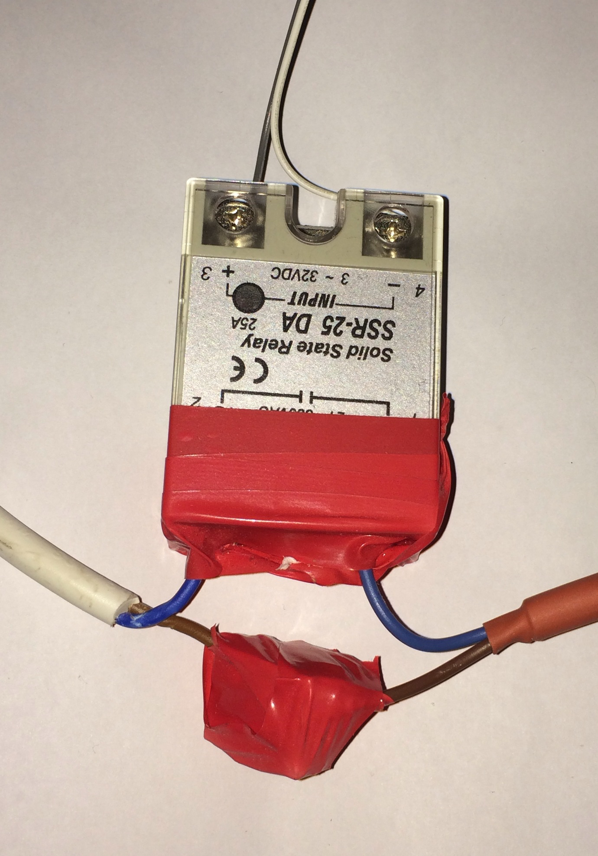

For relay outputs (high power), the power cable must be cut near the plug and reassembled with the power line and device power lines connected, and the two grounds going into the relay on the output side. This will be done and secured properly for the presentation, and is 100% safe with it insulated like this as I have used the correct (screw in block) connectors. **These should not be tampered with at all while the power is on, and plugs will be fitted for the project presentation.**

# Required Software Dependencies

I have not provided the following libraries with my code, as they are not my work and I have used them to accompany my work, if it were to be distributed I would be required to contact each development team and ask permission to use their libraries for a profit organization and request a license or permission. However, in the use for a university project the developers are okay with using the libraries and they are to a large extent open source.

Firstly, I downloaded and installed the arduino IDE[4] for my computer’s operating system, and then I added each of the following libraries into the IDE. These will be loaded by the final code deliverable at the end of this document and on a media storage device so they do not need to be loaded again. Ethernet and SPI libraries are built in to the IDE so they do not need to be added.

EasyScheduler Library[1]

<http://blog.protoneer.co.nz/arduino-task-scheduler>

DHTLib[2]

<https://arduino-info.wikispaces.com/DHT11-Humidity-TempSensor>

MySQL_Connector 1.0.3 (and sha1.h)[3]

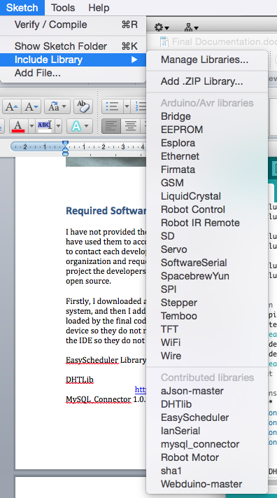[https://launchpad.net/MySQL-arduino](https://launchpad.net/mysql-arduino)

Once you have the required libraries, install them inside arduino so they are added as contributed libraries. The ideal way to do this is click the “Add .ZIP Library’ and find the desired downloaded library.

There is no need to include the library again as all required includes are already made, as long as the IDE knows where to find the library.

Now you can open the required code file provided and upload it to the desired board (please ensure the correct board type and port are selected in the ‘Tools’ tab).

# Development

As I decided to obtain some hardware from distant locations some shipping, my arduino Mega board was lost, so the seller had to ship a second board. During this time I continued my research, webpage design, database design and finally asked a friend if I could use his Uno board when the Ethernet shield arrived.

I believed beginning with the official webserver code would be beneficial as a starting point for work as it is thoroughly tested and is known to work by the hardware manufacturers and all developers on the board. From this I added the details gathered using the DHT11 library for each sensor at given pins. Originally I did this with multiple variable names and as my coding ability advanced through other module areas in computing, I implemented changes such as arrays to hold values so that for loops could easily display and edit multiple values iteratively.

The webserver currently checks for clients that are waiting to receive the page data, and sends each line of html and header data to the browser, adding in key variables and generated sensor data through the process.

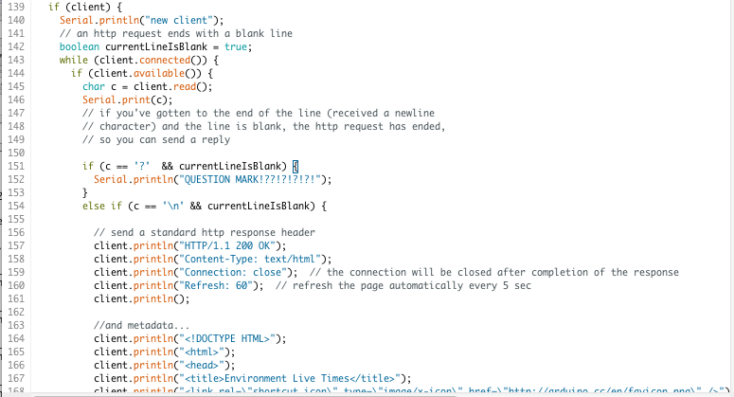

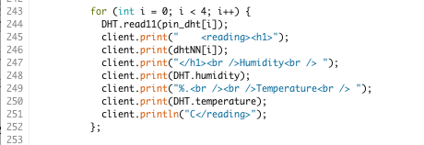

A lot of time was taken developing the key functionality for the MySQL connector, such as informing the server of any updates that are made to the relays as well as having regular interval transmitted data of temperature and humidity for later use in the graph and as a log. This took me the first couple of months alongside the webserver as I attempted to run my own methods of scheduling functions to produce this.

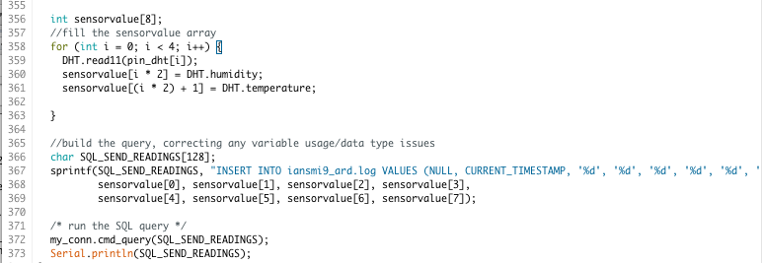

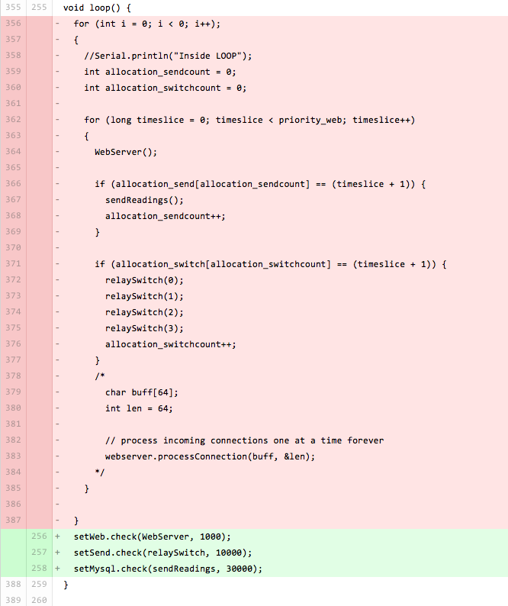

I had attempted time sliced ‘for’ loops and a switch case index handling method of scheduling, which led to crashing of the loop() function and the web server did not respond very often. I recently found a new library that was not available during the initial development phases, which seems to work perfectly and has corrected many of the issues I was having. These advances can be seen on my github account. The way presented above used to fill an array at startup that held timeslice numbers that each function should run at – for example, an array could contain {1000,2000,3000,4000} providing there were 4000 time slices (priority_web) and the function was called 4 times during that interval.

When I found the easy scheduler library, I had already developed working methods for the system functionality and so the function names simply had to be provided to the scheduler. I believe the library works by incrementing an index each time the loop is run, and then the module is run every X loops where X is declared in the implementation of easy scheduler. This manages the timings of the web server, MySQL sensor log and sending of updates to the second board. If the arduino is busy with MySQL or the second board when a webpage request is made, the webserver will hook and transmit data to the client when it is ready and usually loads the page with significantly lower than a second and a half total access time across a network. I cannot see that this would increase much except for transmission latency due to the internet service provider, which would still make average load speed less than one and a half seconds. Although this is relatively slow, for a small device doing as much as the arduino is, I believe that is acceptable. Users would not be accessing more than one page so there is not an issue with repetitive slow responsiveness to perform a task.

The values sent to the second arduino are wrapped into a string with a specific syntax (as covered in my mobile engineering course) so that more than one value can be entered and decoded at the second arduino. The start and stop bit syntax I have added so that no other message sent will trigger the second arduino to change relay states. I am utilizing the onboard RX and TX pins to use the Arduino’s onboard UART, but could have used a software serial library to send data over any digital pin, or even wireless Bluetooth or Wi-Fi transmission. As there is not much distance between the boards, and I aim to make a cheap packable system, I have focused on wired data transfer and it works very well. I wrap the start bit (#), the intended relay, a space, and a 3-digit PWM value, followed by the stop bit ($). I could have added some validation to ensure that only 7 bits of data are received, however if no other device can connect to the RX port of the receiver then it is not required. The first arduino will never send anything other than what the protocol specifies, unless it is a mishandled ‘print line’ or through noise interference, and this syntax will remove those issues.

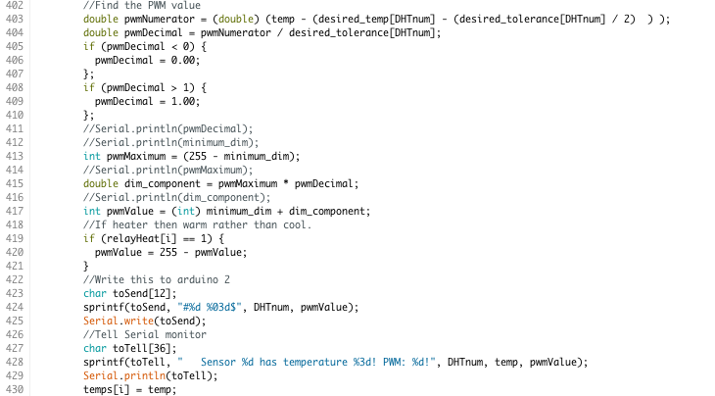

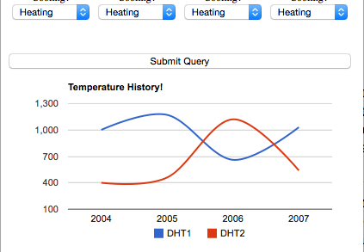Finally, I aimed to implement Google charts into my webpage, which I did not complete since obtaining what is now 3000 rows from a log database crashes the arduino. In the future I will clear the database table of all testing data and start with set times between each MySQL log (around once every 40 minutes, for example) or create a SELECT query that returns all values ‘WHERE’ the date is (for instance) newer than 1 week ago. Alternatively I could manage the graph externally through an iFrame on a separate server that was able to use the PHP language to parse the MySQL data however, the aim here was to interface with an arduino web server directly so I focused my time elsewhere. A graph is displayed but values are currently the default Google ones.

The desired temperature, tolerance and dimmable arrays declared do work as requested and PWM values sent reflect those set. If the desired temperature is 20 degrees C, and the tolerance is 4, then at 20 degrees the heater/cooler will be at 50% PWM, keeping it a constant temperature, if the temperature was to change up or down then the PWM value would increase or decrease to speed up the fan or warm up the heat mat or light as required (and vice versa).

The minimum PWM (for devices that struggle at low power such as fans), heat device dimming setting (as well as cooling), dimmable and non-dimmable options, desired temperature and tolerance range features are working and I have included some key code from that below. I added minimum PWM as some fans do not like having less than around 50% momentum. The lowest value at all times (unless off) is the minimum PWM and the remaining fraction of dimming is scaled accordingly. As I started using heat mats, supporting only cooling became a problem so I implemented this as well as the minimum dim feature as it was proven useful once development began.

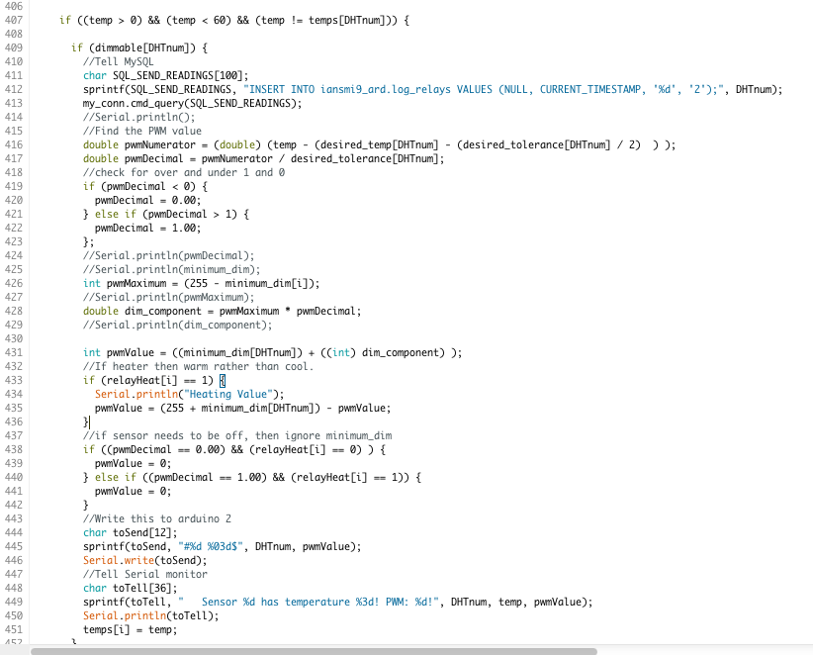

As all the features of the automated system work, the product would perform all it’s uses at home, and the MySQL tables can be accessed remotely from any device with phpMyAdmin access. It would have been a much better finished product if the arduino variables responded to the form requests from the user’s web browser to directly alter the functionality of the system remotely. It does show data from sensors via the Internet which is very useful for checking on the system when on holidays and away from home – but I do feel that I should have returned to the code to solve this, paid more notice to the original schedule that allowed ample time to web functionality development, and been prepared for the anticipated difficulty to implement. In the future I will write a strict log of all known issues and steps found to help find solutions to fix the problem, rather than attempting to fix many solutions in different areas of code simultaneously.

I am proud of many key features, mainly my automated switching and setting techniques which have been finely tuned and modified many times. Testing has been thorough over the previous months and code changes made during this time have been merged into the main branch on my github account.

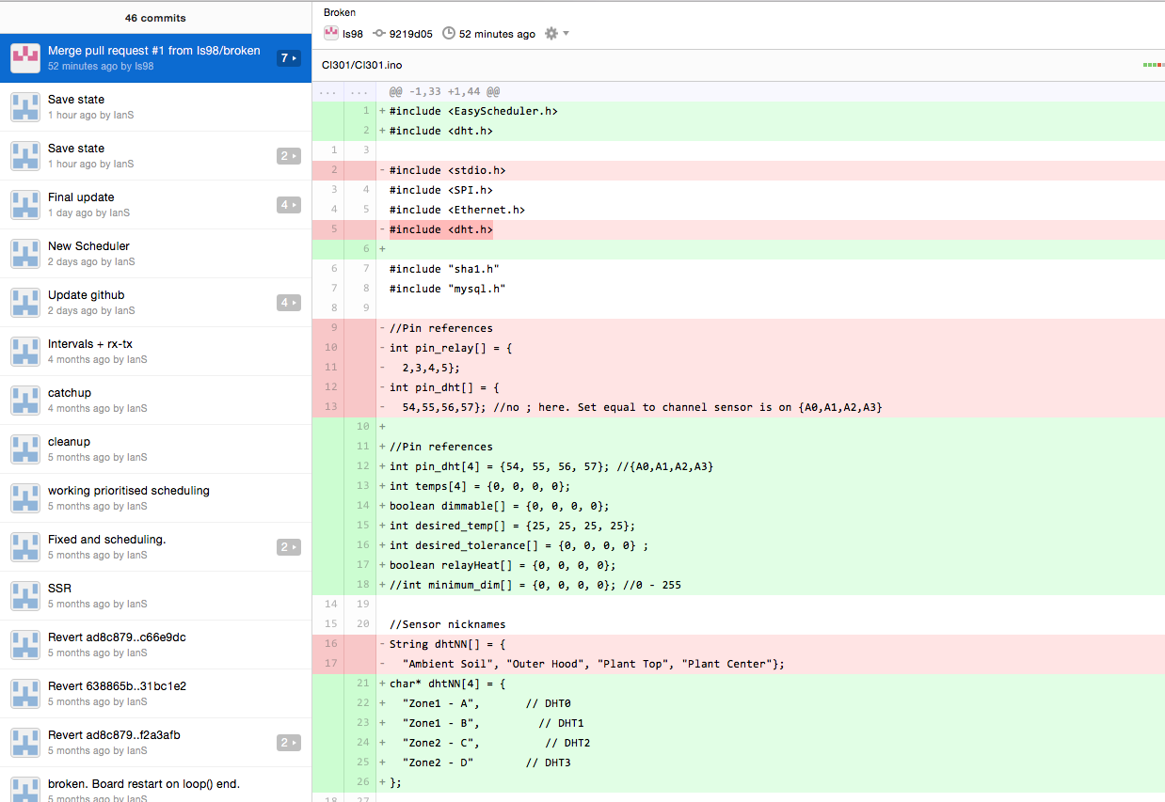

# Time management

I originally stated the following time frame would be imposed

# Task Allocated Finish Time

1 Obtain hardware 15 days "Fri Oct 24, '14"

2 (1a) Research AC ‘dimming’/switching options 10 days "Fri Oct 17, '14"

3 (1b) Research database software options 2 days "Tue Oct 21, '14"

4 (1c) Research graphic data representation options 3 days "Fri Oct 24, '14"

5 Webpage design 5 days "Fri Oct 31, '14"

6 Database design 5 days "Fri Nov 7, '14"

7 Hardware wiring/preparation 2 days "Tue Nov 11, '14"

8 Familiarization with the arduino environment and hardware 3 days "Fri Nov 14, '14"

9 Familiarization with HTML and CSS 3 days "Wed Nov 19, '14

10 Webserver implementation 2 days "Fri Nov 21, '14”

11 Database to arduino connectivity implementation 3 days "Wed Nov 26, ‘14

12 Power handling using code 2 days "Fri Nov 28, '14"

13 Webserver development [HTML/CSS] 15 days "Fri Dec 19, '14"

14 Setting changing development 10 days "Fri Jan 2, '15"

15 Finalizing a sellable hardware form factor 15 days "Fri Jan 23, '15"

16 Quality check and code cleanup 15 days "Fri Feb 13, '15"

17 Testing 20 days "Fri Mar 13, '15"

Obtaining the hardware took a little more time than expected but I resolved this as stated in the Hardware chapter. Researching AC dimming took a long time as I was checking many home made circuit board plans for complex zero cross tracking techniques as discussed in the plan. The webpage design I produced on paper and originally hoped for multiple style sheets for different types of devices, however as I wanted to send the style sheet from the arduino rather than through an external server. I designed the current layout to be displayed clearly on both mobile, tablet and desktop browsers and preceded to implement the starting blocks by using arduino code to implement DHT sensor data into the webpage. As I had gained momentum at these easier stages I had completed the database logging module and the basis of a webserver module by the 7th November.

This was roughly 2 weeks ahead of schedule! I then spent a week or so on different types of scheduling that I had not anticipated causing an issue, but completed database connectivity and insert statements to a log table as well as relay handling by the 8th November. Following this I began to be affected by other external aspects which prevented me from spending time on webserver development .The webserver and setting changing development aspects have had some work in order to present the latest values from the sensors but could benefit from development in areas such as setting variables on the arduino from remote locations through POST and get methods which I did not research as much as I should and assumed the information would be easy to obtain. To some level the information is available but the deep understanding and figuring out the best method to handle certain features takes more time than expected and many problems that I didn’t expect happened to affect the final result.

In the future, I have learnt that it is necessary to keep coding momentum going to keep an understanding of the code through to the end of development. Distractions along the way will take focus off the work and the quality of work produced will not truly reflect the ability possible from the developer. I also learnt that there are many risks that will not be accounted for in a risk assessment and it is crucial to get back into the state of working as soon as possible rather than delaying it.

# Usability/Objectives

I will be criticizing my application based on the original objectives set in my interim planning report as well as general functionality.

230v AC current will be controlled by an arduino based microcontroller.

**This has been correctly handled. The solid state relays are firing at such a high speed that PWM is handling the 240v fans, 60w household (non-energy efficient) bulbs, heat mats and other household dimmable (and non dimmable should that relay be set to non dimmable) devices.**

The entire working product should cost no more than £50 to build.

**Arduino Mega compatible board £12.50**

**Arduino Uno compatible board £5.00**

**Arduino compatible Ethernet Shield £7.00**

**5 x DHT11 Sensors £3.00**

**4 x Solid State Relays £8.00**

**4 x LEDs and a cable kit £2.50**

**Total : £36.**

**This falls in the price range I was aiming for and would be able to make a profit if the code was worked on. At the current time people would use code from competitors, so although the hardware would sell as a kit, the software wouldn’t be sufficient.**

Energy consuming devices should be powered down when feasible within set limits to reduce environmental impact.

**All attached devices are considered energy consuming, if the device is dimmable the software and hardware will dim it to a set percentage slope – set by the desired temperature and tolerance range. The power bandwidth change when dimmed has not been checked, as I do not have a 240v multi-meter but theoretically there should be a drop in overall power used. Fans and heaters give less output visibly and audibly because the relays are turning off for a section of the waveform, and in the off position uses little to no energy. This results in less on time, saving on bills.**

Database records should be made from the sensor readings more than twice per hour and be able to produce a meaningful overview of the environment state throughout the day.

**Readings are sent to a MySQL server that is set up on a 3rd party (currently a freehostia account of mine) and I shall provide a copy of this database structure in the database chapter.**

Produce a user-friendly web page as a front end for the code, so that users aged 15 to 75 can understand what is happening on the system.

**The current view of the webpage is very user friendly in that relays are bundled together and sensor readings are bundled together, and are lay out in a non confusing way using CSS. I believe a 15 or a 75 year old could use the system with just an understanding of how to get to the page, which can be setup as a memorable URL through dynamic DNS should the product be mass produced. It should be noted that the functionality of the buttons currently do not work directly from the webpage as the code is not there to check for POST methods. It realizes when a query is sent which currently displays ‘QUESTION MARK!?!’ in the serial monitor but no action is taken on that value.**

Each power state controller should be capable of sensing and adjusting environment properties up and down. [eg. settings allow a fan to cool, or a heater to heat by adjusting a setting on the GUI frontend]

**I have the variables and front end form view set up to allow for cooling and dimming but as the project has no form capability at this stage the buttons do not work. I have included cooling/dimming support by designing an ‘if’ statement that subtracts the desired PWM (0 – 255) by 255 if heating was enabled. It is currently set up for fans**

Every aspect of the system should be tested and de-bugged entirely. All issues found with hardware interference should be corrected to the best ability possible and solutions found to any repeatable errors.

**See ‘Testing’**

Different ‘zones’ should be recognized linking to different relay switches and operations [relay1 = heating in zone 1, relay2 = cooling in zone 1]

**I have implemented this by saying one relay monitors a certain DHT, in either cooling or warming. This has the same affect if the devices both heat or both cool through a multisocket plug (available separately), however cooling and heating is currently fixed per relay so the sensors would have to be placed together. If zone one needed cooling and heating then DHT0 and DHT1 could be used with heating 0 and 1 respectively.**

**The better way of implementing was if one DHT could be warmed or cooled by up to 4 relays, or 4 DHTs by 1 relay each, or a mixture in between. Relays could have set monitored DHTs so that relay3 could monitor dht1, but there doesn’t seem much need if it is clear on the UI side how zones can be manipulated by settings. This would be done in the send PWM to second board code to check the DHT that was selected for the relay [currently 1 DHT per relay].**

**This would mean if relays monitored contained {0, 3, 3, 2} and relayHeat {0, 0, 1, 1}, then**

**Relay0 would cool based on DHT0’s value**

**Relay1 would cool based on DHT3s value**

**Relay2 would heat based on DHT3’s value and**

**Relay3 would heat based on DHT2’s value.**

**This would be easy to implement with just an extra array and a check for the desired DHT to check rather than my index driven iteration method, but I have ran out of development time due to other modules and personal reasons.**

No longer than 3 months should be spent on the code aspect of the project. Testing and implementation procedures should take no longer than one month after the development has ceased. This includes final packaging and safety aspects of the design.

**I have spent around 3 months on the project in total, and an unexpected pause to development occurred when other commitments happened which led me to continue working on the project in small intervals of time rather than all the time for a short period. Final packaging has not yet been manufactured but I aim to improve the current form factor of the device by the time of presentation if that is permitted.**

No 230v lines should be accessible unless the product is disassembled. This means all terminals should be properly shielded and insulated. Silicon glue could be used as an insulator, or for the final product a plastic molded case that all plugs and timers, screens/terminals screw into, and the front covered from any 3rd party tampering with electrical parts could be used.

**Currently the product is not in a shippable state. All terminals that have 240v lines are correctly insulated and are held in securely to the relay using the supplied screws and hoop terminals. When I have obtained a more secure packaging I will cover all cables and hot glue insulate the wires, supplying plug fittings.**

# Testing

I have been using the product for a while to heat a lizard vivarium for a small snake. The product has been keeping the heat in the left and right areas of the enclosure inside the tolerances set very well, and utilizes different desired temperatures on either side. Here I will break down certain aspects of running the finished product. I will not so into detail with uploading the code and setting up the wiring as I have done that previously in hardware requirements.

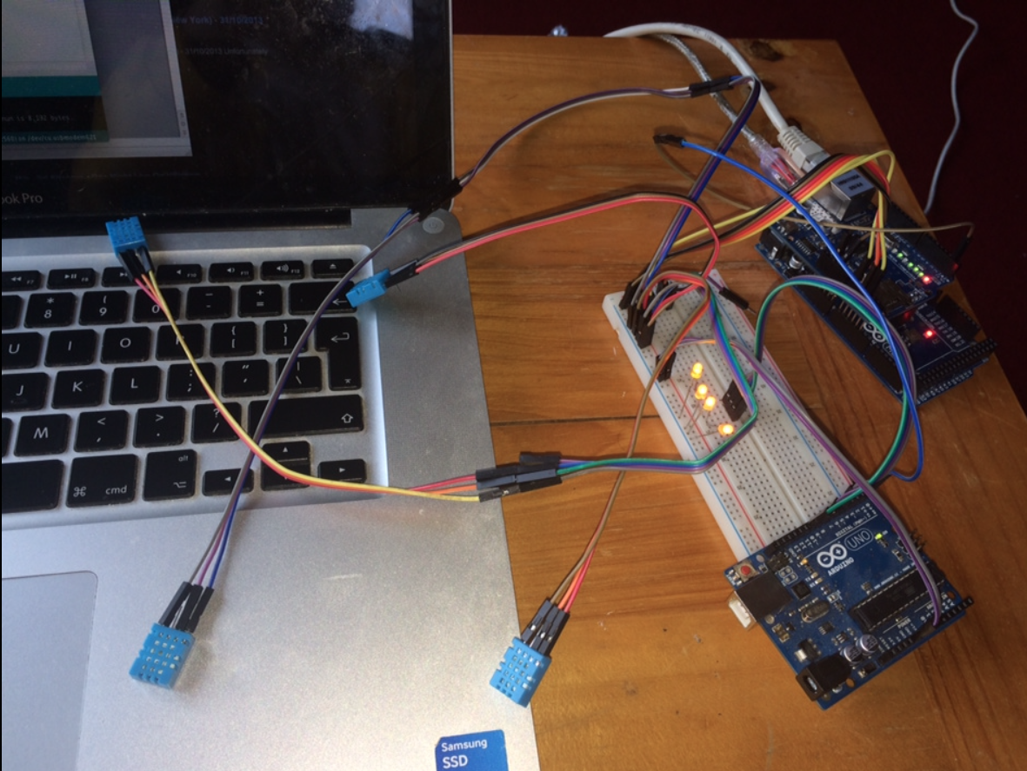

I will consider the functionality of all coding modules provided and address as many possible issues as possible

## No Internet access

The dimming board will receive no values and all relays will be set to off. The main arduino will hang after saying it is about to start, and will produce an error similar to ‘Failed to configure Ethernet using DHCP’. It then retries the entire setup method again and loops the setup method until the Ethernet issue is resolved. I intent to add a small LCD screen to display any issues and current sensor temperature readings.

Before release I would add a small LCD screen, which would warn the user of any issues.

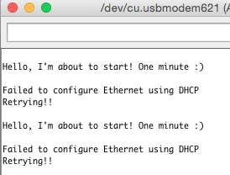

## Incorrect MySQL details

The dimming board will receive no values and all relays will be set to off. The main arduino will stop running after displaying the access error or connection error to the database. It is rather easy to understand there is a database problem. A computer to monitor errors is best during the set up phase, and I still feel that I could have added a small LCD screen to display the issues without the need for a computer. In this case a computer would still usually be required to fix the issue but it would be easier to notice.

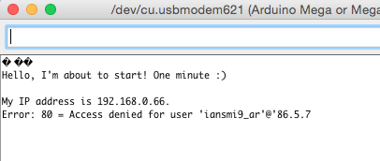

## Power on and serial monitor test

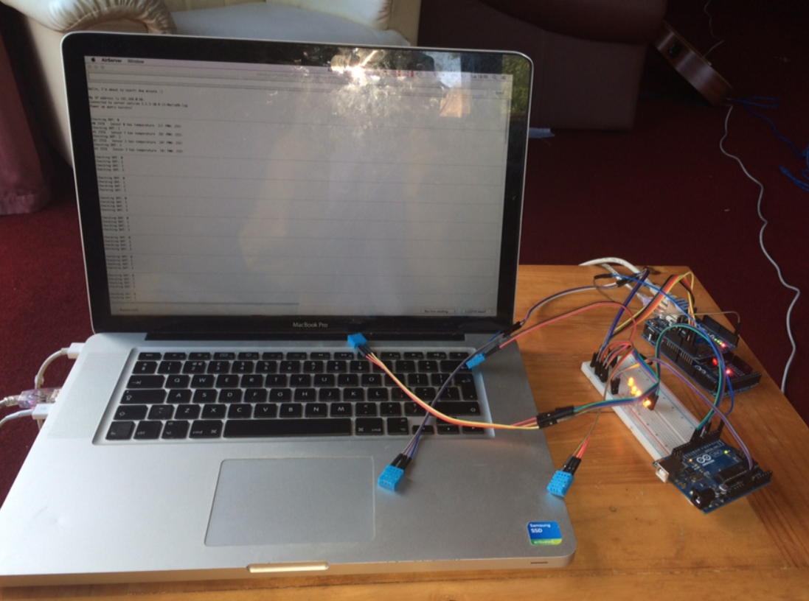

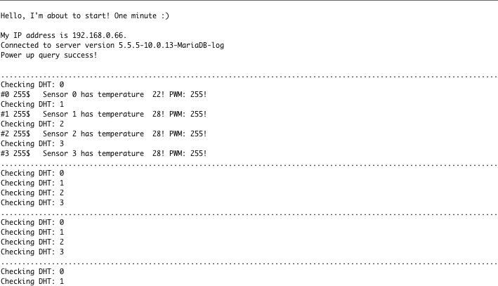

Inside the serial monitor during a working power on test, we are informed that the MySQL database connection was made and the power up query has been sent correctly. Proof the MySQL data is added can be found in the database design chapter in this document. The ‘.’ characters represent web server to client hook checks, it then warns when checking each sensor, and if PWM values need to be adjusted, adjustments will be sent to the second board accordingly.

## Webpage access and access times

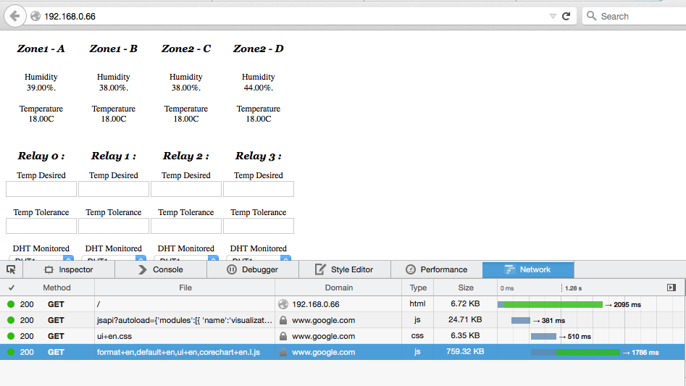

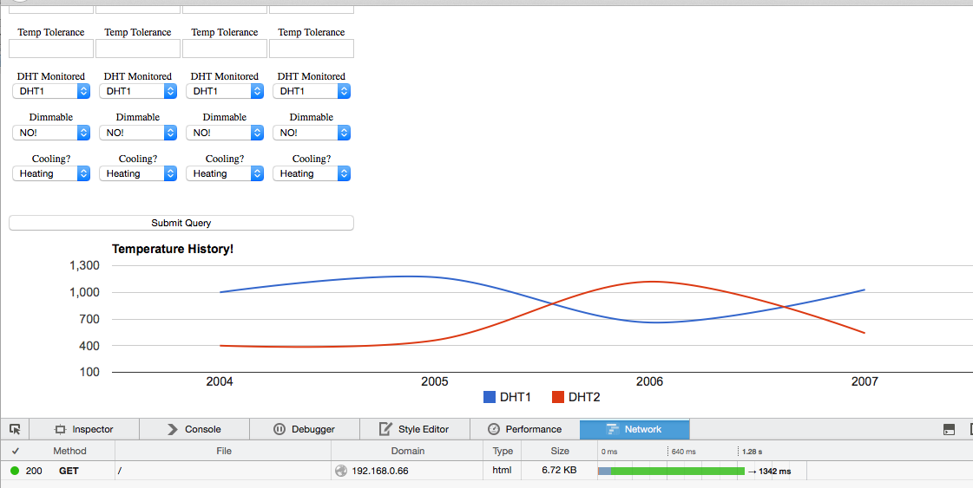

Access times vary but are usually between 1.3 and 1.5 seconds, which is quite high considering no MySQL data is being imported into the webpage. A lot of the processing time seems to be because of the java script on the page and at the current state I could remove this without removing any functionality but I will leave it in for demonstration purposes for how I would utilize the MySQL data (now commented out) and format the responding data using a curser to parse through the table. For household use, up to 2 seconds is acceptable for a small, embedded device. Remote access can be forwarded to the webserver inside the network router’s port forwarding settings to allow port 80 requests to be forwarded to the board.

## Relay dimming with LEDs

I have used solid-state 240v relays to dim or or not dim depending on the device used. Most devices with a transformer or voltage reducer of any kind will not support dimming features but fans, heaters, motors and some lights are ideal for dimming. A picture and description of how to wire relays into the board can be found in the hardware requirements section (relays will be wired with plugs in the final project presentation). I will first test that the main arduino is sending the correct strings to the second board. For this to be true, each value has to be the PWM I would expect for the heating setting, temperature and tolerance and whether dim is set and the minimum non-zero dim functionality. If each relay is sent the right message I will then test that the second board is receiving the correct message and outputting the changes to the LEDs.

## Main Board

### Dimmable hardware (LEDs, many fans, some household lights)

Desired temperature: 18 C 18 C 18 C 18 C

Tolerance range: 6 C 6 C 6 C 6 C

Heating set: 0 0 0 0 (all cooling)

Dimmable set: 1 1 1 1 (all yes)

Minimum_dim set: 0 0 0 0

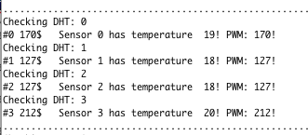

I would expect 50% PWM from the two middle sensors as they are dimmable and are at the desired temperature with no minimum dim to boost the value. The way my minimum dim works is to add a value to the final PWM all the time except when off. It is not a minimum in which values below are replaced by the minimum, but is designed to scale up the regular PWM. I found this worked much better with managing fans and low power dimmable heat mats.

For relay 0, the second board is sent “#0 170$ which matches the relay0 – PWM 170 that has been calculated. The calculation has found each degree to be worth around 43 degrees and has added more cooling to bring the 19 degrees back to the desired 18. Similarly, cooling has been added to sensor 3 to further cool this area if possible.

Desired temperature: 18 C 18 C 18 C 18 C

Tolerance range: 6 C 6 C 6 C 6 C

Heating set: 0 0 0 0 (all cooling)

Dimmable set: 1 1 1 1 (all yes)

Minimum_dim set: 128 128 128 128

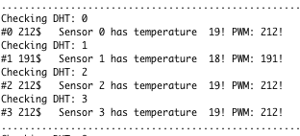

This test was to test the minimum dim setting, which has successfully raised all settings by around 50% (half of the maximum PWM).

Desired temperature: 18 C 18 C 18 C 18 C

Tolerance range: 6 C 6 C 6 C 6 C

Heating set: 1 1 1 1 (all heating)

Dimmable set: 1 1 1 1 (all yes)

Minimum_dim set: 0 0 128 128

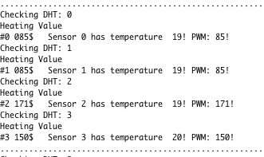

For the heating setting test, I am checking multiple things; that the PWM is now decreasing when temperature increases; that the second board is receiving the new PWM value and that the minimum dim is visible in context. The temperatures at sensor 0 and 1 have the same value which is below 50% PWM, which seems correct if the desired temperature is 18 degrees at 127 PWM. As temperature increases, PWM is decreasing. The board is sending #0 085$ which is the correct syntax and matches the PWM shown, and finally the minimum dim has boosted the same temperature from 85 to 171 PWM, which is the increase I would like to see.

## Non-dimmable hardware

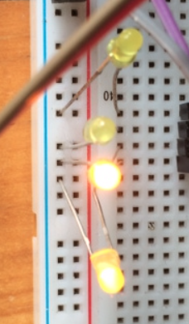Desired temperature: 18 C 18 C 18 C 18 C

Tolerance range: 1 C 1 C 1 C 1 C

Heating set: 0 0 1 1

Dimmable set: 0 0 0 0

Minimum_dim set: 0 0 0 0

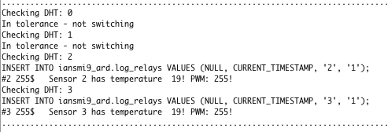

All relays are set to non-dimmable, have a desired 18 degrees and a single degree tolerance. Relay 2 and 3 are heaters, and relays 0 and 1 are coolers. From the serial monitor of the main board, we are told that DHT0 and DHT1 are fine the way they are, and sensors 2 and 3 are too cold so they apply the heating to full power. I have also added the LED image to show that the second board is producing the desired results.

## Secondary Board

Although I do not believe the second board is fully required and I could have in hindsight set the pins on the original board, I do believe it will be able to add future performance benefits by sending it a task to run and return the value at a later time, but then concurrency issues will have to be faced.

At this time the secondary board simply takes the input and sets the PWM of the corresponding relay pin to the PWM sent to it. I will now test a dimmable and non-dimmable option, sent from the original board.

Desired temperature: 18 C 20 C 18 C 18 C

Tolerance range: 4 C 6 C 1 C 1 C

Heating set: 0 1 0 1

Dimmable set: 1 1 0 0

Minimum dim set: 0 0 0 0

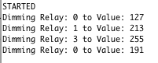Here is the secondary board’s serial monitor output for those settings. From this we can see that at the initial startup, the first board sent #0 127$ for the first pin (50% PWM). The second board does not care about the temperature at that point, and simply sets the relay pin 0 to half power. The second relay was used for heating and is wants to be at 20 degrees, with less of a PWM slope. The result sent shows that the sensor must have been at 18 degrees at the time because the PWM wants to heat up the area by increasing PWM to around 80%. At 17 degrees the PWM would be at the edge of its tolerance and would run at full power. For the third and fourth relays, the only possible states are on, off or “I’m inside my tolerance, so stay like that”.

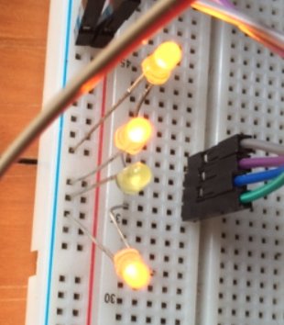In this example, relay2 does not require any adjustment because it’s not too hot for it’s tolerance and has no need to turn on so saves power consumption. Relay3 however is set as a heater so it realizes it needs to be turned on: as there are no dimming options it is set to 255 (entire wavelength of power is permitted). From this example we also see a change in temperature occurred to a dimmable relay that changed the 127 to a 191. This is due to an increase in temperature at that pin so the cooling adjusted itself to solve the issue.

The results in relation to their PWM are visible in the picture to the right.

Remember, Relay2 (light 3) is off because there is no need to cool it, and it cannot be dimmed.

It is also clear to see here that the lights get brighter from 0, to 1 then 3 as expected.

I have also tested relays in their place and all pins work as desired with fans, lights and heat mats but I will demonstrate this, as it will be more difficult to display proof than LEDs in a document.

# Database Design

I originally planned to have separate database tables for each sensor and during implementation I realized that there is no need for this. As the code was modular based it was easy to find the code to change and I used string formatting to include the sensor values obtained in the INSERT query.

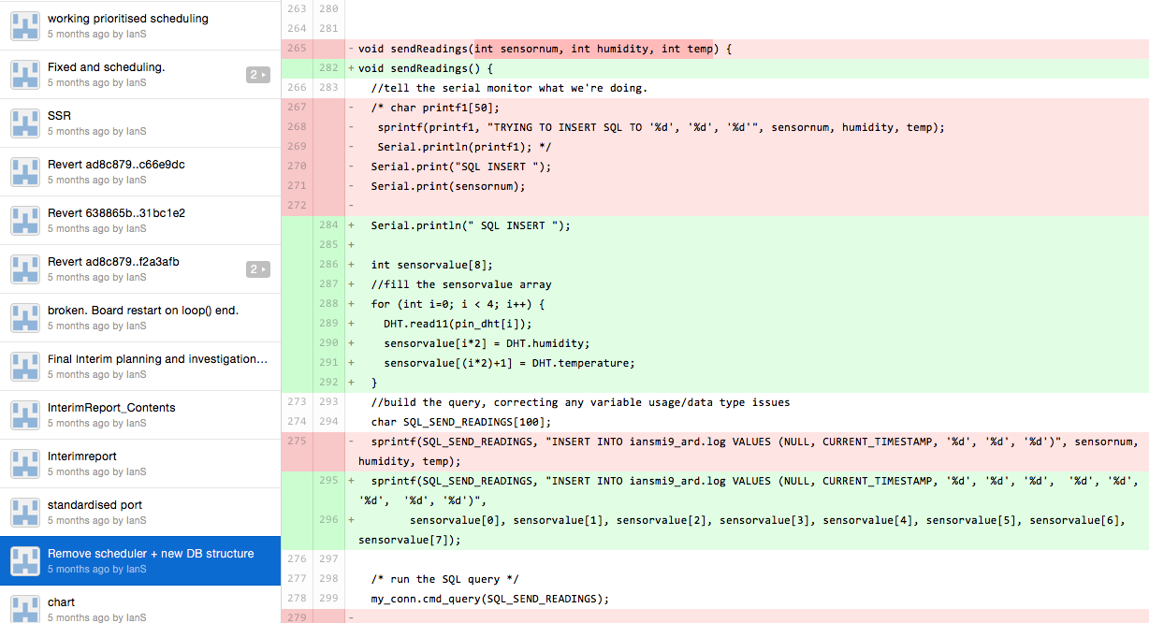

This is the latest design of the log table.

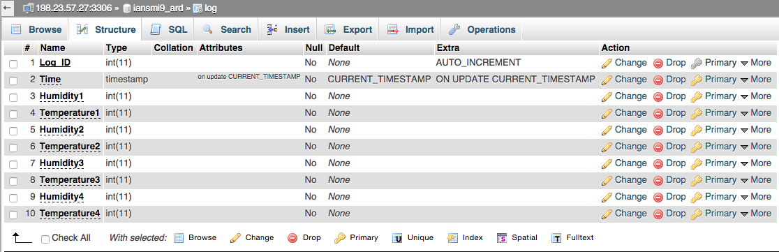



This has an auto-incrementing index (primary key) and an automatically added timestamp, the application only has to send over the humidity and temperature for the 4 relays. I numbered these 1 to 4 instead of 0 to 3 because I was originally handling only one sensor and worked up to the 4, and so the array implementation came after the database design and it still functions very well.

The ‘poweron’ table was created in early development to monitor when the arduino was powered on, simply to test the connection to the MySQL server was functioning. Here is what it stores…

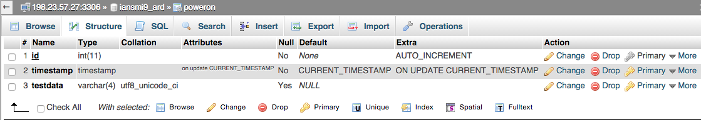

and here’s some test data. The table provides an ID and a timestamp when the data ‘ok’ is sent to it.

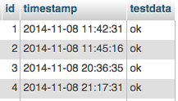

In order to test when the dimming was occurring (and for pointer plotting on future graphs) I also included a log_relays table in order to check when the state of a relay had changed.

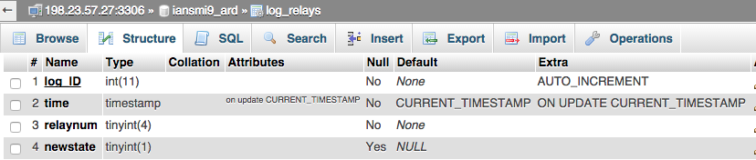

A record contains an ID, an automatically generated timestamp and the arduino sends the relay number with the changed state and a new state value. This is currently either a 0 for off, 1 for on or a 2 for dimmable. I could change the table to allow for PWM values to be saved too and that would take very little time. This would produce a better look when implemented into graph data, but at this stage it would not be very useful.

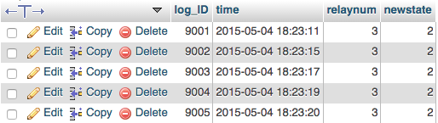

From this it is clear there was a steep change in the temperature at sensor 4 (dht3 = sensor 4) or it was just between two temperatures causing rapid changing of PWM. Changing the scheduling frequency can increase or decrease the number of checks and variables could be later added to edit scheduling times.

# Evaluation

As the main aspect of the project was to produce an automated system that could be monitored from a web browser, I feel that the code performs the tasks it originally aimed to do, and is to a high standard with many relatively deeply thought aspects. There are areas that are incomplete such as the unpopulated graph and non-working form element of the web site. Now I feel that getting the MySQL select functions to work would increase the website’s load time unless I added separate tabs to load the graph separately.

To add the values posted from the web form into arduino variables wouldn’t be too difficult of a task and would simply be a repetitive process of breaking part the URL content and using a series of switch case selections to get the correct variable value for dimming or heating selections. I think with a little more time the project will be up to the standard originally planned in the interim report.

There is also the issue of the extra expense of the second board, and it would have been easier with a working loop scheduling function earlier in development. I added the second board simply to remove all relay activity away from the main board to relieve processor stress on the first board, however now I feel it would use just as much with wrapping the desired content and sending it to the second board as it would take to set a pin value. Before this was not the case because the loop function would not loop and after my 40 minute lifecycle it would stop working. I tried to resolve this many ways until finding the solution and now one board would be sufficient reducing the cost to around £30 including the expense of solid-state relays.

If the product was to ever be considered for public release or resale I would contact the developer teams of each library I used in the project, ask for permission and request any licensing information from them.

I have mentioned “in hindsight” several times throughout this document, but a few key areas could have been solved more easily if I had checked every possible method of doing a task rather than making my own method. In particular I would have used a scheduling library, which would have given me more time elsewhere. The original plan I set was very accurate in timings and I was ahead of schedule for the vast majority of the work, but more could have been done to improve on an already working system. The important objectives are working except the web front end, and this system suits me as a user more than any other alternative code I have found online and is very stable. With minor, well-planned adjustments it could be used by many people in a variety of environments (including home heating with professional installation) and it would be cheaper than most household dimming sockets.

As a part of my course I decided to take the Mobile Engineering course, which taught me certain aspects of code used within this product. An example being the use of the RX to TX UART transmission built into the board to send a string of data, which has been used alongside my own syntax to stop the board from being confused between logging and state changing requests.

I have also hinted on future possibilities of adding concurrent processing across two boards, which has been taught in detail in the concurrent and server side programming module. If I were to have more time I would probably remove the second board rather than keep it as a lot of scheduling time is available and the board seems to cope with only a fraction of it’s memory used. A smaller board than the Mega would not be recommended as the board will not hold the full storage size required for this amount of code.

# References

1. Webpage, http://forum.arduino.cc/index.php?topic=140740.0 13th/11/2014

2. Webpage, http://arduino.cc/en/Products.Compare 13th/11/2014

3. Webpage, http://uk.rs-online.com/web/c/?searchTerm=arduino 13th/11/2014

4. Webpage, http://www.adafruit.com/category/35_66 13th/11/2014

5. Webpage, http://arduino-info.wikispaces.com/RelayIsolation 13th/11/2014

6. Webpage, http://www.ni.com/white-paper/4125/en/ 13th/11/2014

7. Webpage, http://www.ubasics.com/adam/electronics/doc/phasecon.shtml

13th/11/2014

8. Webpage, http://uk.mouser.com/ProductDetail/Crydom/5LPCV2415/?

qs=mNyg5qXQ/scbLKFdq7sicg== 13th/11/2014

9. Webpage, https://developers.google.com/chart/ 13th/11/2014

EasyScheduler Library, <http://blog.protoneer.co.nz/arduino-task-scheduler>

DHTLib, <https://arduino-info.wikispaces.com/DHT11-Humidity-TempSensor>

MySQL_Connector 1.0.3 (and sha1.h), [https://launchpad.net/MySQL-arduino](https://launchpad.net/mysql-arduino)

Arduino IDE, <http://arduino.cc/en/>

# Ethics Form

**SCHOOL OF COMPUTING, ENGINEERING & MATHEMATICS ETHICS FORM**

This ethics form is designed to help you quickly and easily identify how you should approach any ethical issues raised by your project or dissertation. It should be completed for ALL research projects and dissertations prior to the commencement of the project. Please do not approach any participants involved in the research until this have been completed and discussed with your supervisor or member of the CEM ethics committee (if appropriate).

This form must be completed by the project student or researcher responsible for the project. Once completed, you should discuss it with your supervisor to ensure that you take the right follow-up actions.

**If you answer ‘No’ to all questions** **in this form and this is confirmed with your supervisor (if appropriate) then no further action is required.** Please note that in signing this form you accept that it is still your responsibility for your project or dissertation module to follow the **University’s Guidance on Good Practice in Research Ethics and Governance**, available on StudentCentral. Any significant change in the question, design or conduct of your project or dissertation that would alter your answers on this form must be notified to your supervisor who will advise you on whether you need further action.

**If you have answered ‘yes’ to *any* of the questions in Section B of the Student Checklist your supervisor will need to make a judgment as to whether or not the research includes more than a minimum level of risk. If this is the case then your supervisor will need to email this form to the CEM ethics committee (**[**CEMethics@brighton.ac.uk**](CEMethics@brighton.ac.uk)**) for discussion prior to the commencement of research**.This does not mean that you will not be able to do the research, but it will need to be considered by the School Research Ethics and Governance Committee.

Ethics forms, example consent forms/participant information sheets and supporting guidance are available on the ***Research Ethics for Projects – CEM*** area of StudentCentral.

**Signed copies of this completed ethics form must be submitted with your project or dissertation. Note: the project or dissertation will not be marked if the completed checklist is not included.**

**PROJECT DETAILS**

1. Name of researcher: Ian Smith

2. Name of supervisor: Saeed Malekshahi Gheytassi

3. Title of project: Arduino based Web Server for Environmental Control

4. Outline of the research (up to 100 words): No public hands-on involvement with the project.

5. Location of research: Using available online information only

Not ethically applicable.

6. Email address: contact@simstop112.co.uk

7. Contact address: 3 Selba Drive, East Moulsecoomb, Brighton, East Sussex. BN2 4RG

8. Telephone number: 07706 129 330

| **Please tick the appropriate box and answer the questions where appropriate.** | Yes | No |
| --- | --- | --- |
| 1. Does the study involve **participants who might be considered vulnerable** due to age or to a social, psychological or medical condition? (*e.g. children, people with learning disabilities or mental health problems, but participants who may be considered vulnerable are not confined to these groups).*   If yes then provide details of any such participants. See the University’s ‘Guidance on Good Practice in Research Ethics and Governance’ for more details.  ……………………..……………………..……………………..……………………..………..……………………..………..  ……………………..……………………..……………………..……………………..………..……………………..………..  Note: proposals involving vulnerable participants are often likely to require ethical approval from the Faculty of Science & Engineering Research Ethics and Governance Committee (FREGC). |  | ✔ |
| 1. Will **photographic or video recordings** of research participants be collected as part of the research?   If yes then please outline consent and data protection procedures *(e.g. interviews cannot be overheard, details will not be accessible to others),* for the use of participants’ images. Example consent and information forms can be found on StudentCentral and see guidance on data collection at the end of this document.  ……………………..……………………..……………………..……………………..………..……………………..………..  ……………………..……………………..……………………..……………………..………..……………………..………..  If your data will not be confidential and anonymous then outline the justification for this decision here and procedures for mitigating against potential harm.  ……………………..……………………..……………………..……………………..………..……………………..………..  ……………………..……………………..……………………..……………………..………..……………………..……….. |  | ✔ |
| 1. Does the study require the **co-operation of an individual to gain access** to the participants? (*e.g. a teacher at a school or a manager of sheltered housing)*   If yes then describe the procedures that will be put in place to ensure safe and ethical direct involvement of human participants. Where necessary and as appropriate, include comments on obtaining informed consent, reducing harm, providing feedback, and accessing participants through an individual providing information such as a teacher/lecturer, manager, employer etc. Example consent and information forms can be found on StudentCentral.  ……………………..……………………..……………………..……………………..………..……………………..………..  ……………………..……………………..……………………..……………………..………..……………………..……….. |  | ✔ |
| 1. Will the participants be asked to discuss what might be perceived as **sensitive topics** (*e.g. sexual behaviour, drug use, religious belief, detailed financial matters) or* could participants experience psychological stress, anxiety or other negative consequences (beyond what would be expected to be encountered in normal life)?   If yes then describe the procedures that will be put in place to ensure safe and ethical direct involvement of human participants. Where necessary and as appropriate, include comments on obtaining informed consent, reducing harm, providing feedback. Example consent and information forms can be found on StudentCentral.  ……………………..……………………..……………………..……………………..………..……………………..………..  ……………………..……………………..……………………..……………………..………..……………………..……….. |  | ✔ |
| 1. Will individual participants be involved in **repetitive/prolonged testing or vigorous physical activity, experience pain of any kind, or be exposed to dangerous situations, environments or materials** as part of the research?   If yes then describe the procedures that will be put in place to ensure safe and ethical direct involvement of human participants. Where necessary and as appropriate, include comments on obtaining informed consent, reducing harm, providing feedback. Example consent and information forms can be found on StudentCentral.  ……………………..……………………..……………………..……………………..………..……………………..………..  ……………………..……………………..……………………..……………………..………..……………………..……….. |  | ✔ |
| 1. Will members of the public be **indirectly involved** in the research without their knowledge at the time? (*e.g. covert observation of people in non-public places, the use of methods that will affect privacy)*.   If yes then provide brief details here *(e.g. how they will be involved and, where known, the age, gender, ethnicity and location of those who will be indirectly involved).*  ……………………..……………………..……………………..……………………..………..……………………..………..  ……………………..……………………..……………………..……………………..………..……………………..………..  Provide details of any negative impacts members of the public will be likely to face and that would not be considered minimal impacts (e.g. invasion of privacy, harm to property, being subject to what an individual perceives to be inappropriate behaviour). Describe the risks and if appropriate explain why you believe they are only minimal.  ……………………..……………………..……………………..……………………..………..……………………..………..  ……………………..……………………..……………………..……………………..………..……………………..………..  Describe any procedures that will be put in place to ensure safe and ethical indirect involvement of members of the public (*e.g. providing information and feedback if requested by the public*). Examples of participation information forms can be found on StudentCentral.  ……………………..……………………..……………………..……………………..………..……………………..………..  ……………………..……………………..……………………..……………………..………..……………………..………..  Describe how you will ensure data collection is confidential and anonymous (*e.g. people will not be able to be identified by photographs or notes taken by observers*), how data will be stored and who will have access to the data. If the data will not be confidential or anonymous, outline the justification for this decision here and procedures for mitigating against potential harm.  ……………………..……………………..……………………..……………………..………..……………………..………..  ……………………..……………………..……………………..……………………..………..……………………..……….. |  | ✔ |
| 1. Does this research include **secondary data** that may carry personal or sensitive organisational information? *(Secondary data refers to any data you plan to use that you did not collect yourself, e.g. datasets held by organisations, patient records, confidential minutes of meetings, personal diary entrie).*   If yes then provide details regarding any secondary data to be used that may carry sensitive personal or organisational information.  ……………………..……………………..……………………..……………………..………..……………………..………..  ……………………..……………………..……………………..……………………..………..……………………..………..  If secondary data CEMs containing sensitive personal or organisational information are to be used, outline how such use will be ethically managed *(e.g. details such as anonymising data CEMs, ensuring protection of source agency, gaining consent of data owners, and how the data will be stored)*. See guidance on data collection at the end of this document.  ……………………..……………………..……………………..……………………..………..……………………..………..  ……………………..……………………..……………………..……………………..………..……………………..……….. |  | ✔ |
| 1. Is this research likely to have significant **negative impacts on the environment**? (*For example, the release of dangerous substances or damaging intrusions into protected habitats.)*   If yes then provide details of these impacts here (for example the release of dangerous substances or damaging intrusions into protected habitats) and  ……………………..……………………..……………………..……………………..  ……………………..……………………..……………………..……………………..  Describe how you will mitigate against significant environmental harm and manage risks.  ……………………..……………………..……………………..……………………..  ……………………..……………………..……………………..…………………….. |  | ✔ |
| 1. Will any participants receive **financial reimbursement** for their time? (*excluding reasonable expenses to cover travel and other costs*).   If yes then provide details and a short justification (e.g. amounts and form of reimbursement).  ……………………..……………………..……………………..……………………..………..……………………..………..  ……………………..……………………..……………………..……………………..………..……………………..……….. |  | ✔ |
| 1. Are there any **other ethical concerns** associated with the research that are not covered in the questions above?   If yes then give details here.  ……………………..……………………..……………………..……………………..………..……………………..………..  ……………………..……………………..……………………..……………………..………..……………………..……….. |  | ✔ |

**All Undergraduate and Masters level projects or dissertations in the School of CEM must adhere to the following procedures on data storage and confidentiality.**

All data should be encrypted and stored securely. Documentation should be kept in a locked cabinet or desk, and electronic data should preferably be kept on a removable disk or data stick which can be locked away, or if this is not possible on a password protected computer. Confidential and sensitive data should not be emailed unless it is encrypted or password protected since emails are centrally archived.

For Undergraduate/Masters projects, normally only the student and supervisor will have access to the data (see the University’s ‘Guidance on Good Practice in Research Ethics and Governance for further details).Once a mark for the project or dissertation has been published, all data must be removed from personal computers, and original questionnaires and consent forms should be destroyed unless the research is likely to be published or data re-used. If this is the case a justification for this should be included where appropriate in this form and in the relevant consent and participant information forms.

**Student:** Please sign below to confirm that you have completed the Ethics form and will adhere to these procedures on data storage and confidentiality.

Signed (**Student**): ………………..………..……………………..………..

Date: ………………..………..……………………..………..

**Supervisor**: I confirm that the research ***does/does not*** (delete as applicable) include more than a **minimum level of risk**.

Signed (**Supervisor**): ………………..………..……………………..………..

Date: ………………..………..……………………..………..

Note: If the **supervisor judges** that there is more than the **minimum level of risk** then your supervisor will need to email this form to the CEM ethics committee (<CEMethics@brighton.ac.uk>) for discussion prior to the commencement of research.